AS11 -

Functionality

The term "asset" is used for simple assets, as well as for complex large-scale assets that consist of a number of component assets. The data structure of the system, with a 12 character alpha-numeric main asset number and a 4 character sub-number, allows both. The main asset number represents the asset as a whole. Parts of assets can be represented by different sub-numbers.
Features
Every master record is automatically created with at least one sub-number, even if no sub-assets exist. The system marks the first master record as an asset main number master record. When you use internal sub-number assignment, this main number has sub-number "0000". You can create additional sub-numbers for this main number master record. The system manages values for each sub-number for every individual depreciation area in year segments. The individual transactions are posted directly to the sub-numbers as line items.

Scenario
This system task is used to create an asset sub-number.

Requirements
Asset master.

Menu Path | Accounting → Financial Accounting → Fixed Assets → Asset → Create → Sub-Number → AS11 - Asset
Transaction Code | AS11

1. Double Click on AS11 - Asset

Create Sub-Number: Initial screen

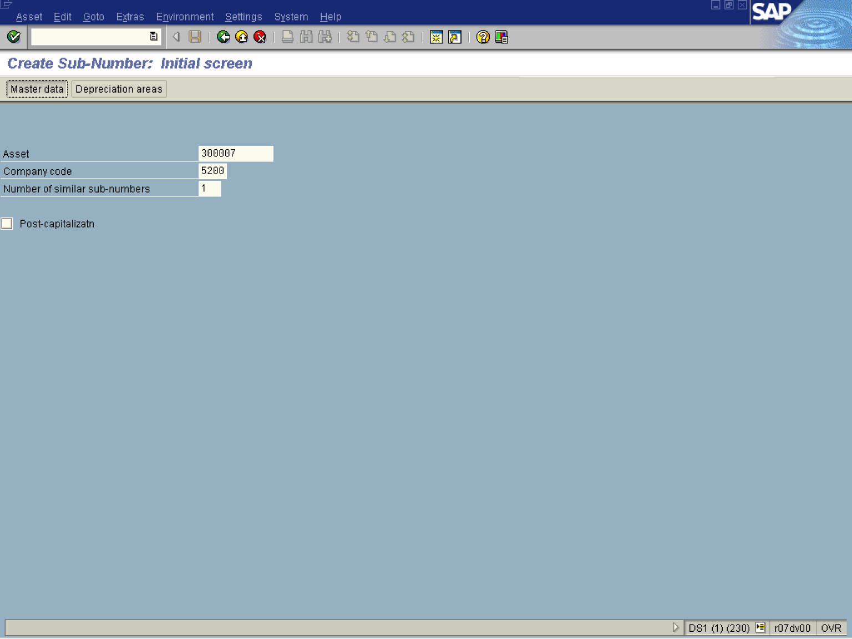

Note: Notice the system automatically assigns the first sub-number.

2. Click Master data Button .

Create Asset: Master data

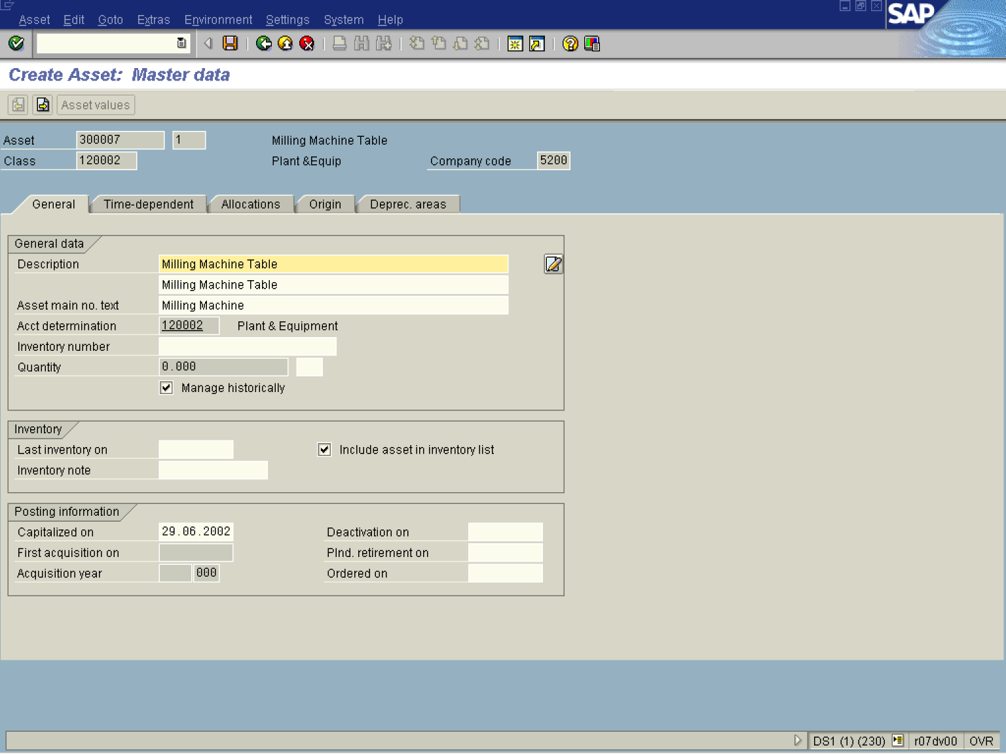

3. Update the following fields:

Field Name | Field Description | Values
Description | Enter a name for the asset in this field. | Example: Milling Machine Table
 | Enter a name for the asset in this field. | Example: Milling Machine Table

4. Click the Enter button to validate the entries.
5. Click <tab button> Time-dependent .

Create Asset: Master data

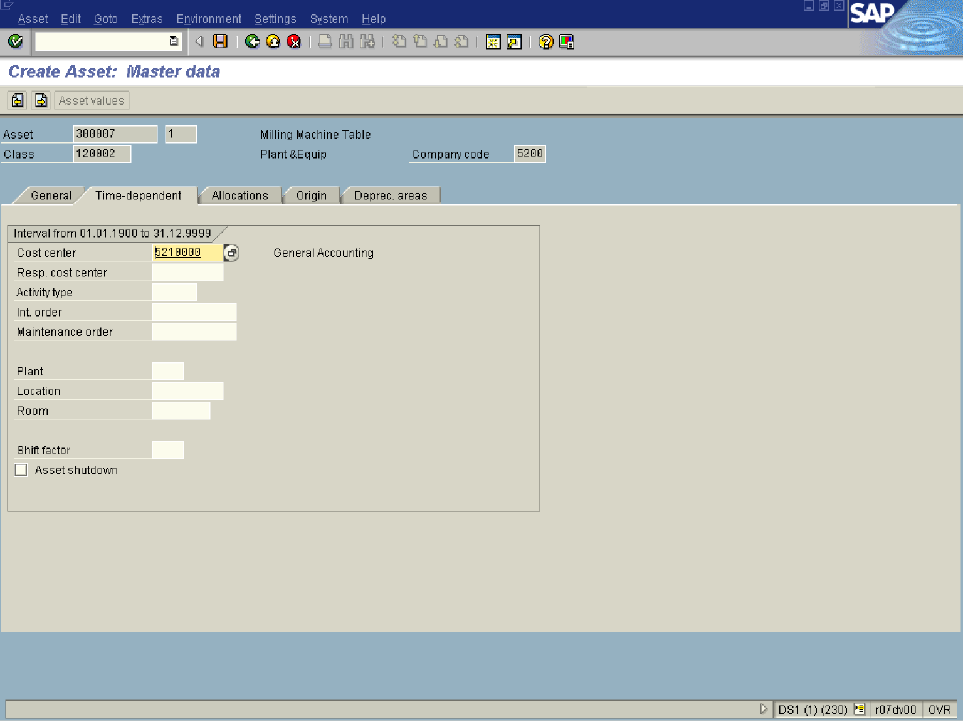

Note: All of the master data from the parent asset master record are adopted to the sub-asset master record.
6. Click <tab button> Allocations .

Create Asset: Master data

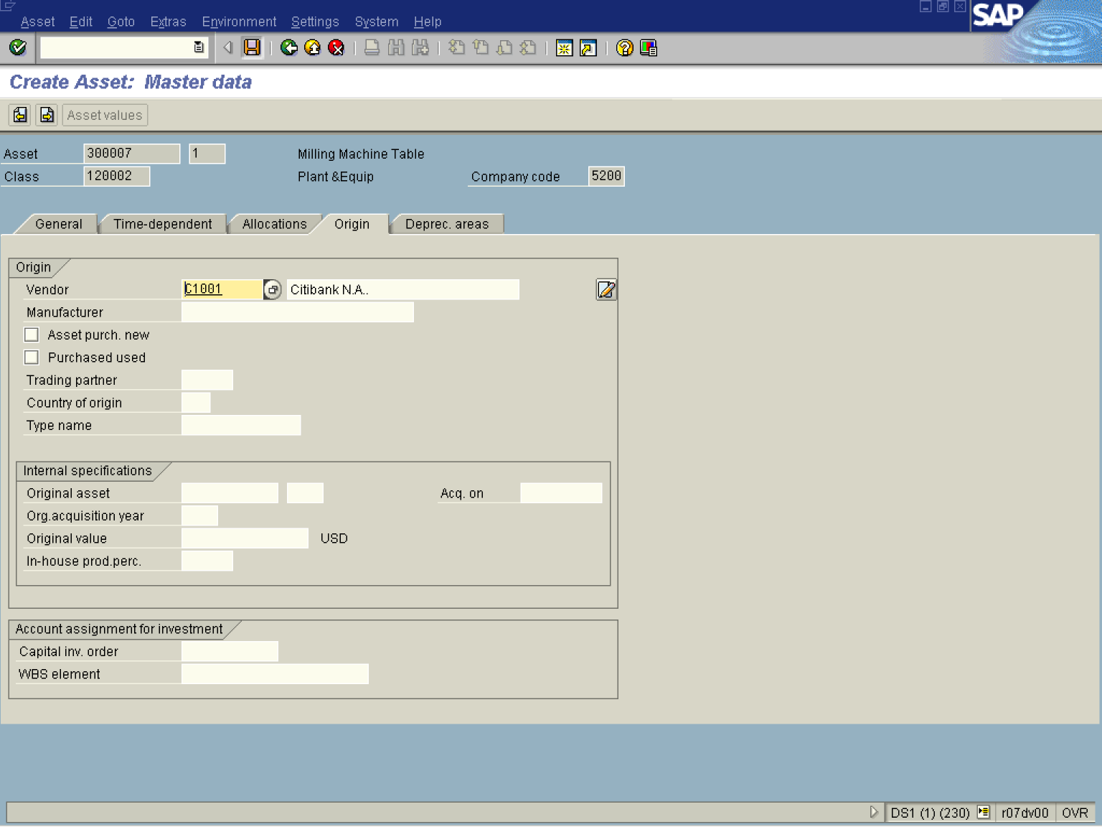

Note: Once all relevant data has been maintained, the sub-asset can be saved.

7. Click the Save button.

Create Sub-Number: Initial screen

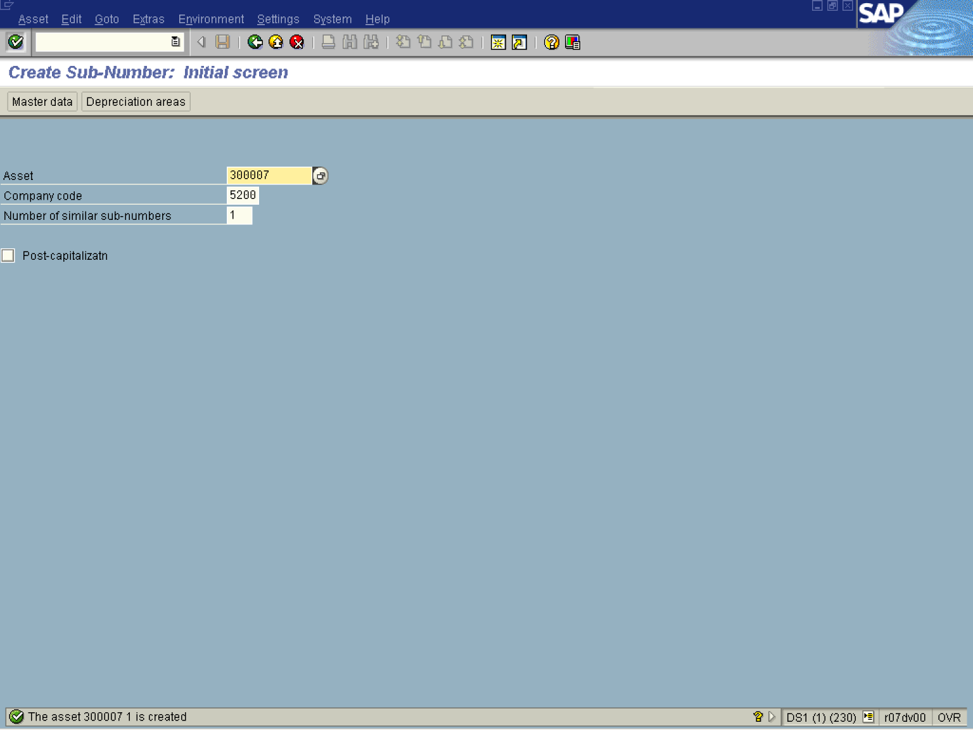

Note: Notice the new asset sub-number has a one at the end. 3000007 1

